GWAttachmentStats (v3.2)
(As of version 3.2, this tool will now work with logs generated by either the Standalone or ConsoleOne, according to the parameters specified below)
We have determined that much of our total GroupWise storage is due to attachments that are left in users' mail boxes. Many of these attachments are dated and can be buried in a user’s Cabinet folder for reference, or still exist as Sent or Trashed item. We can significantly reduce our GroupWise storage space without resorting to global policies to delete or archive messages if we could identify these messages with attachments for the users, and provide them with a report of the messages with attachments and request that they "clean house".
Though the GWCheck program provided by GroupWise does give the ability to report on mailbox statistics, and find this information, the resulting log does not lend itself to be imported into a spreadsheet or database for reporting purposes.
This utility program, GWAttachmentStats.exe, parses out a GWCheck report generated to report attachment statistics. With an options file defined like this:
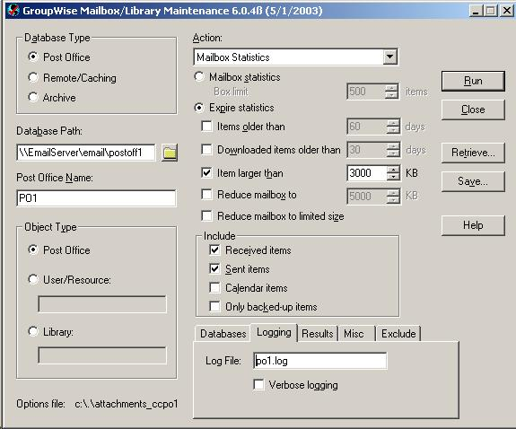
Here we are reporting on all messages with attachments larger than 3 MB, it will process the resulting log file into 2 tab-delimited files, SUMMARY.TXT and DETAIL.TXT, which is then easily imported into Excel for reporting purposes. The SUMMARY.TXT gives mailbox statistics for each user, and the DETAIL.TXT provides the information about the messages containing attachments that meet the GWCheck report criteria. When you first run GWAttachmentStats.exe, you'll be prompted whether you want to run a GWCheck report:
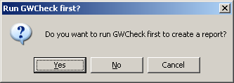
If you answer yes, GWCheck.exe will be launched

We take this:
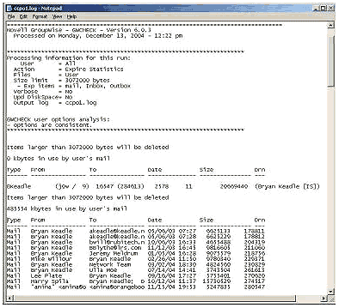
And turn it into a tab-delimited text file which can be imported into a spreadsheet or database program.
Now we can easily report, sort, and trend on user’s email statistics, mailbox sizes, and space taken by attachments!
If you just want the summary information, and don’t need the DETAIL.TXT report, simply add the word SUMMARY to the command line.
GWAttachmentStats SUMMARY
Or, deselect the Detail check box when prompted:
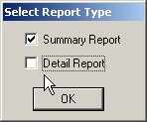

If Excel is installed, you'll be prompted whether you would like to import the tab-delimited files into excel:
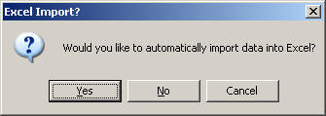
By answering Yes, the generated reports will automatically be imported into Excel as separate worksheets in a single workbook, formatted, and column totals generated, and saved as GWAttachmentStats.xls. Subsequent processed files will be added as additional worksheets:
SUMMARY
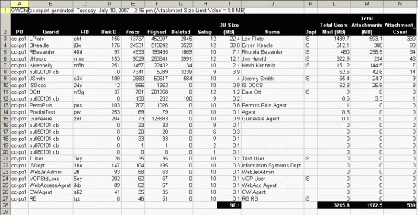
DETAIL
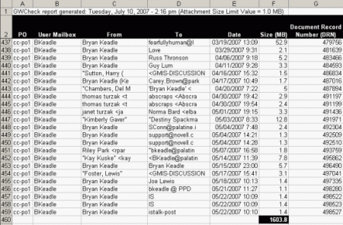

The first cell (A1) will show the date of when the GWCheck log file was generated, and the attachment size parameter that was used. The worksheet tab includes the report type (Summary or Detail), the PO name that was processed, and the day that the summary file was generated.

TIP:
As a matter of policy, we would request that users save out email attachments that are important, and delete them from their mailbox. Alternatively, there is a handy Formativ Applet by Advansys that allows you to delete the attachment from a message, without deleting the message.

